Project Design Phase-II

Data Flow Diagram & User Stories

|  |  |
| --- | --- |
| Date | 17 October 2022 |
| Team ID | PNT2022TMID10120 |
| Project Name | Natural Disaster Intensity Analysis and Classification using Artificial Intelligence |
| Maximum Marks | 4 Marks |

# Data Flow Diagrams:

A Data Flow Diagram (DFD) is a traditional visual representation of the information flows within a system. A neat and clear DFD can depict the right amount of the system requirement graphically. It shows how data enters and leaves the system, what changes the information, and where data is stored.

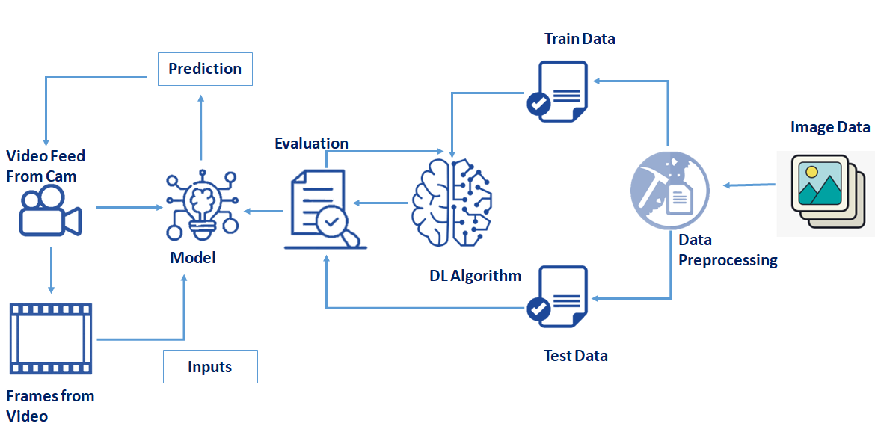

# User Stories

|  |  |  |  |  |  |  |
| --- | --- | --- | --- | --- | --- | --- |
| **User Type** | **Functional Requirement**  **(Epic)** | **User Story**  **Number** | **User Story / Task** | **Acceptance criteria** | **Priority** | **Release** |
| Customer (Mobile user) | Upload Data | USN-1 | As a user, I can upload either a live stream, video or photo of the disaster | I can upload the data. | High | Sprint-1 |
| Customer (Mobile user) | Obtain Output | USN-2 | As a user, I can receive the classification and the intensity of the  disaster | I can receive the information about the disaster | High | Sprint-1 |
| Customer (Web user) | Upload Data | USN-1 | As a user, I can upload either a live  stream, video or photo of the disaster | I can upload the data. | High | Sprint-1 |
| Customer (Web user) | Obtain Output | USN-1 | As a user, I can receive the classification and the intensity of the disaster | I can receive the information about the disaster | High | Sprint-1 |